**Product Designer Magento 2 Module.**

**1. Installation.**

Installation should be done through Magento 2 admin panel.

After opening Stores >>Configuration >>Advanced >> Advanced, the module will be shown in the admin panel

**2. Configuration**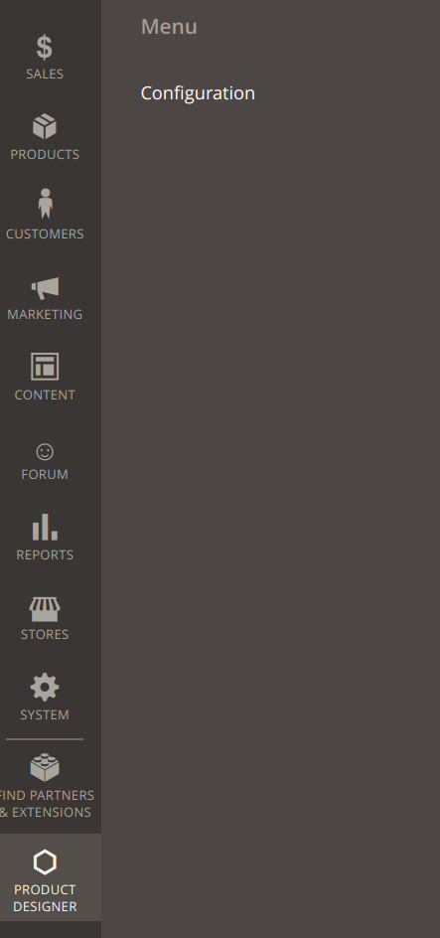

Adminpanel right menu, select Product Designer → Configuration.

**General Settings.**

Disable enable product designer module for frontend.

**General → Enabled**

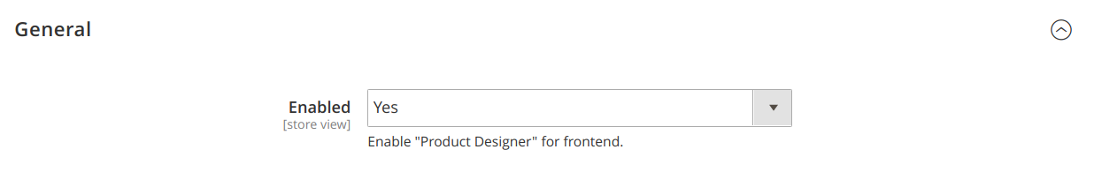

**Frontend Settings**

Disable/enable for all products. If set to yes, all products will have ability to use designer on frontend.

**Frontend → Enable for All products**

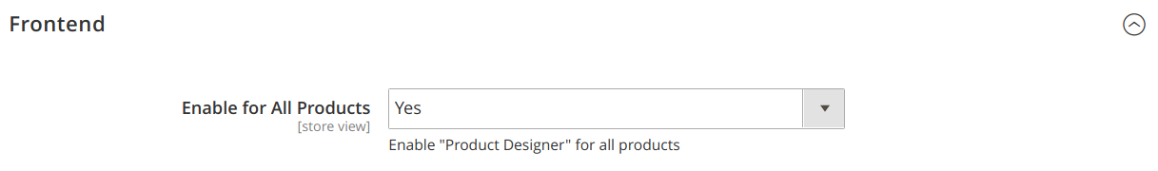

As result on frontend each product would have «**Customize It**» button

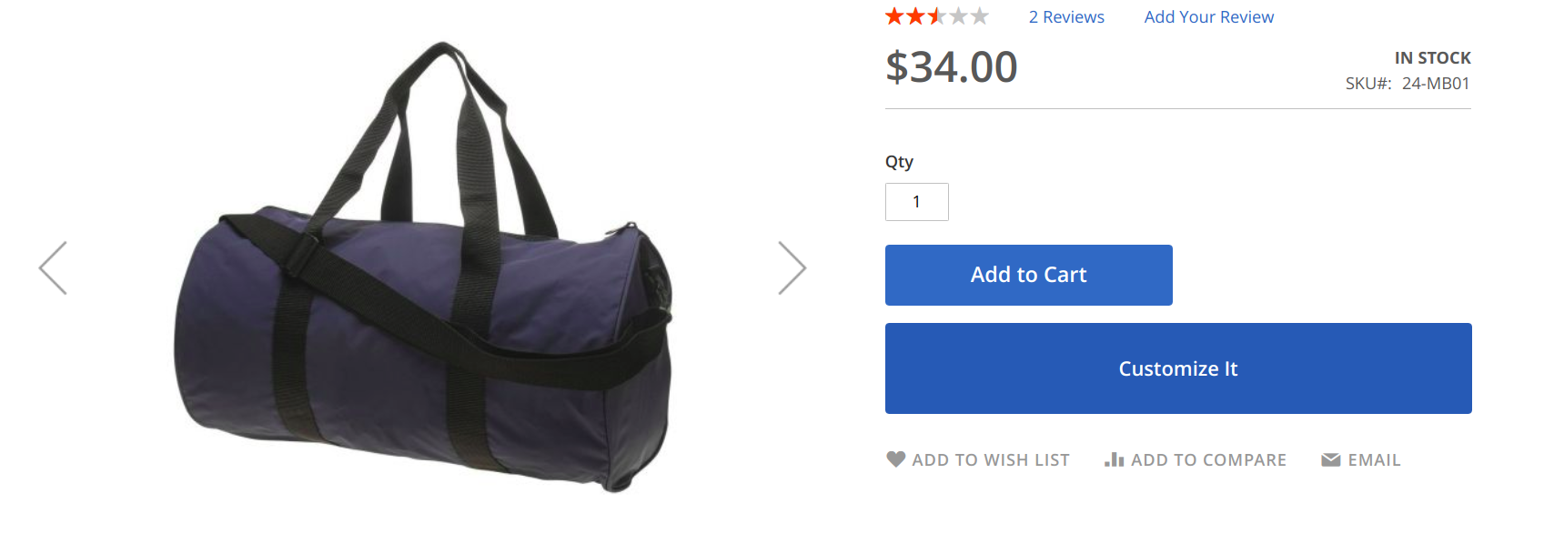

After click on it open modal with «Product Designer» functionality.

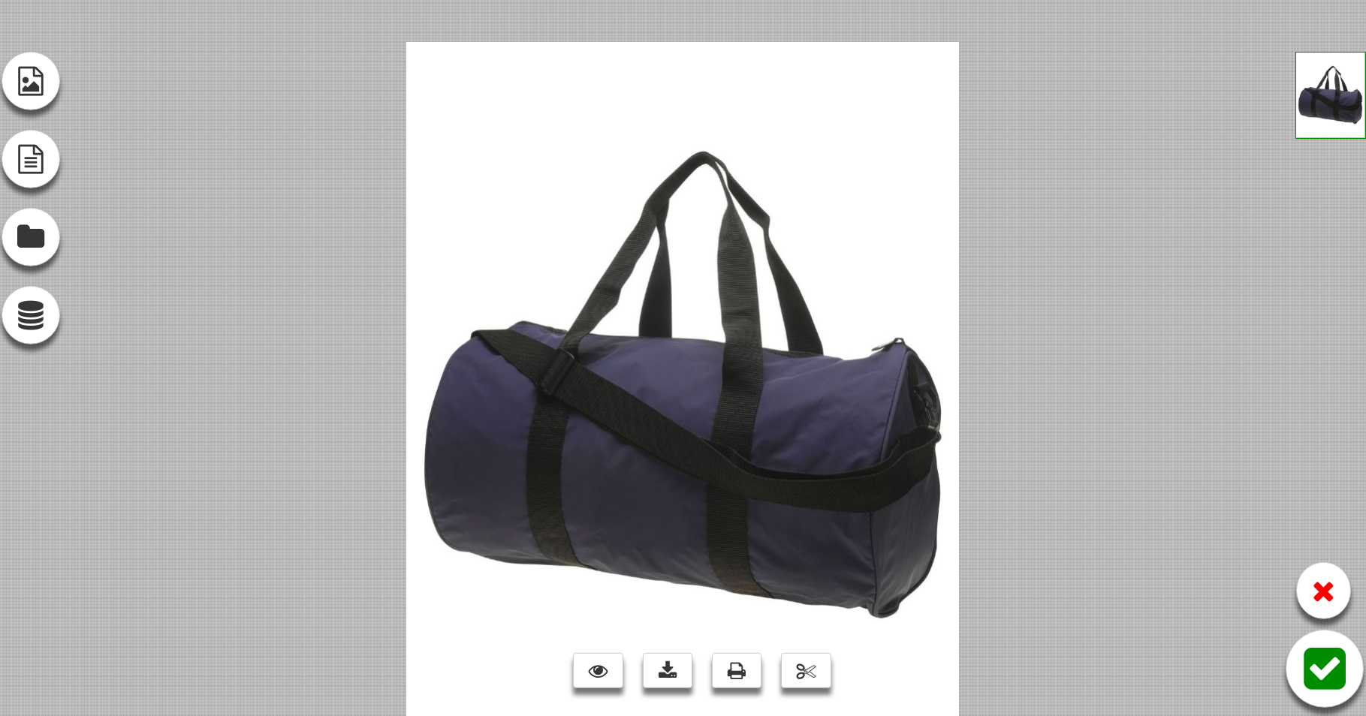

Its also possible to allow «Product Designer» only per some specific «Magento Attributes Sets»

Set **Frontend → Enable for All products**  to **«NO»**

Then use **Frontend →**  **Enable for Attribute sets**

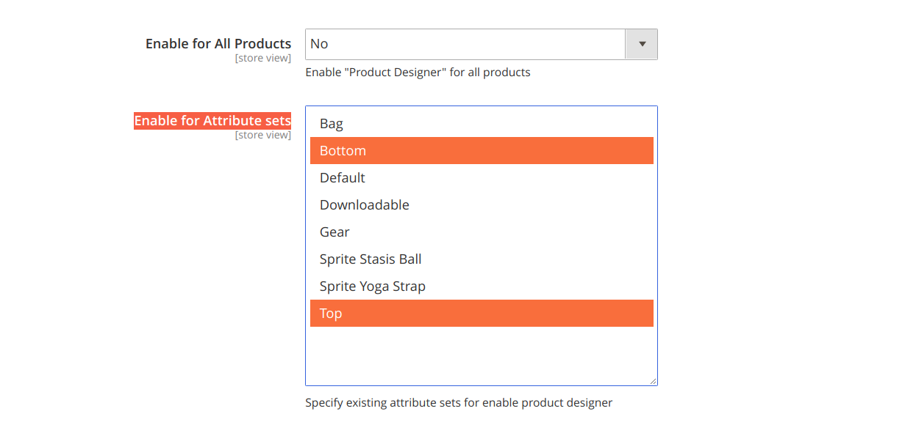

**Frontend → Google Fonts to load**

Configure custom google fonts to be loaded and used in «Product Designer» module



**Frontend → Enable add Image(default yes)**



Enable/Disable upload/add images front «Product Designer» view

Front view:

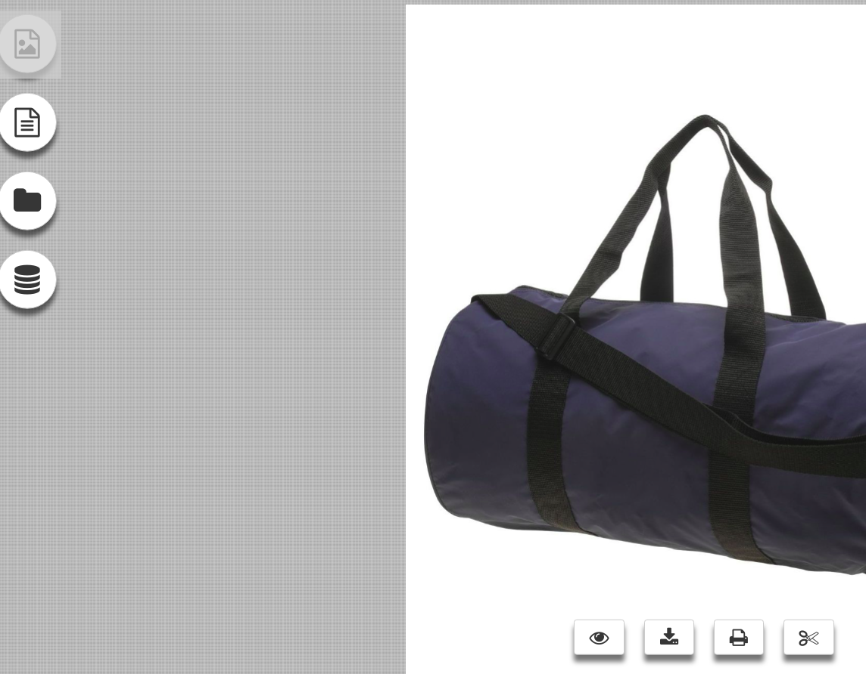

**Frontend → Enable add Text(default yes)**



Enable/Disable add text front «Product Designer» view

Front view:

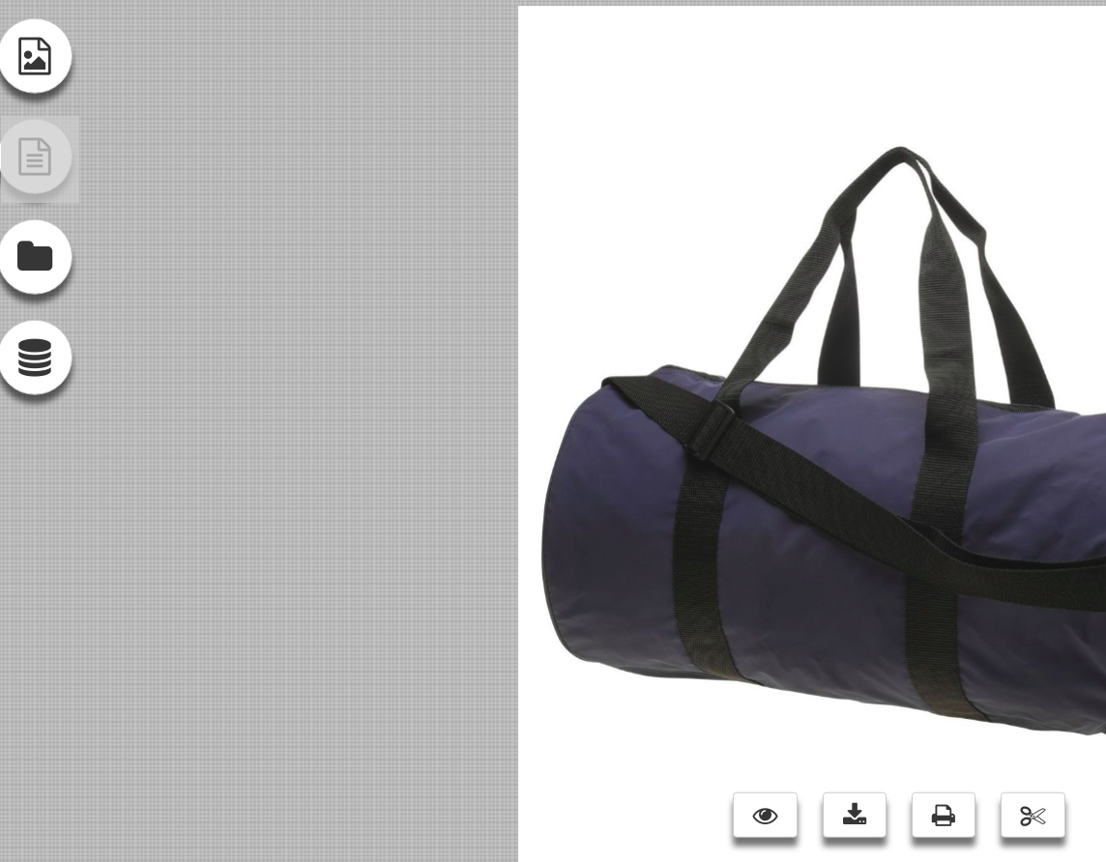

**Frontend → Enable Add From Library(default yes)**



Enable/Disable add from library «Product Designer» view. Images(or svg) grouped by category folders.

To manage them use FTP (SFTP), folder — {root}**/pub/media/dd_library/default/**, simply add edit folders with images. Folder name is category name in «Product Designer» front view

Front view:

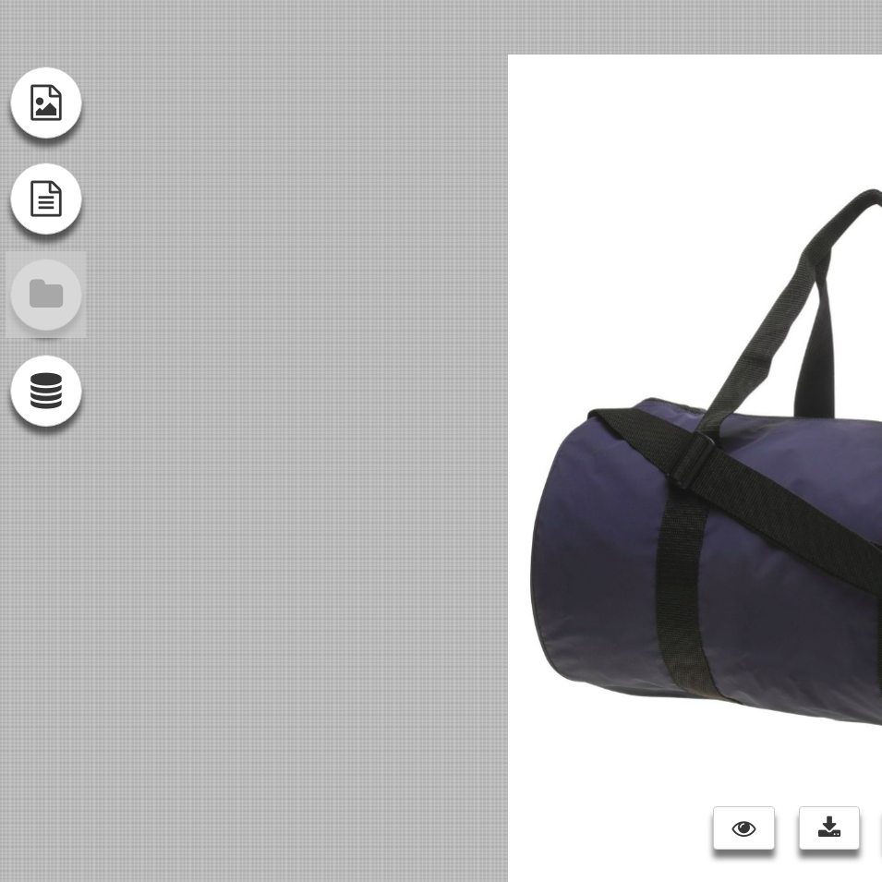

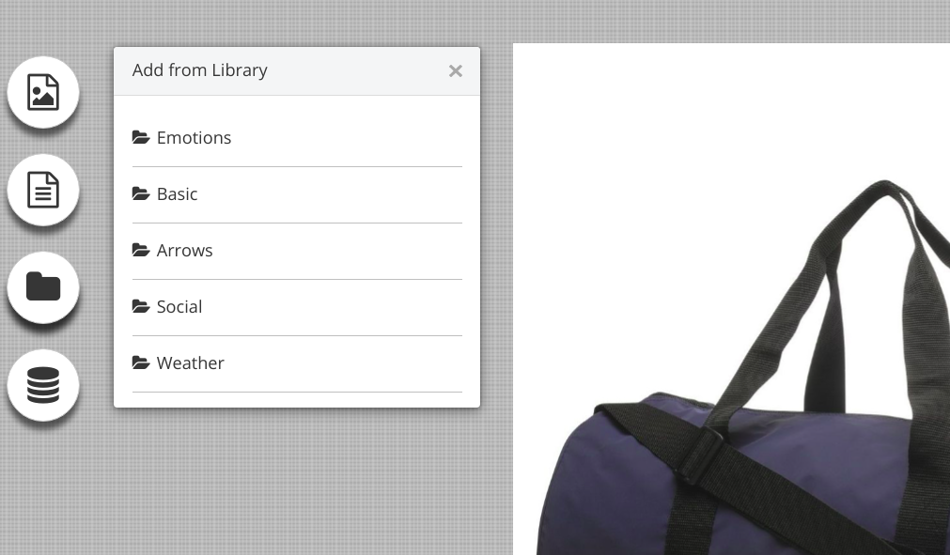

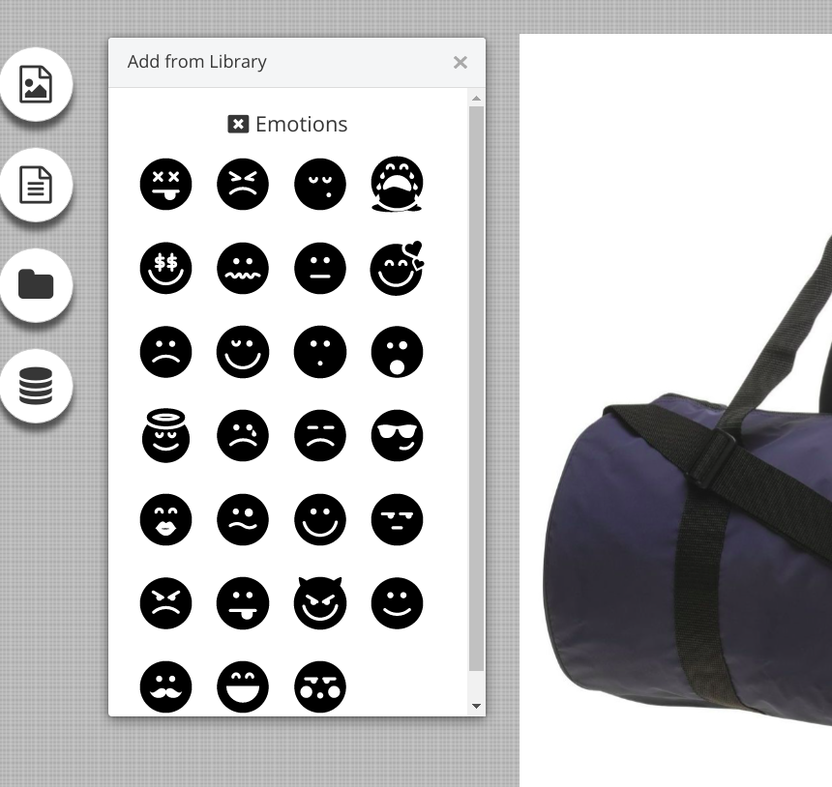

**Prices Settings.**

Setup prices per each layer in base shop currency. If store use another currency, price will be converted with configured rates.

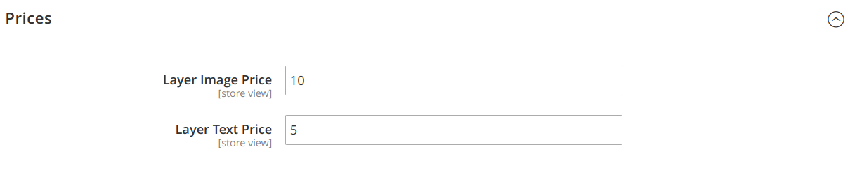

As result each layer(image or text) increase base product price.

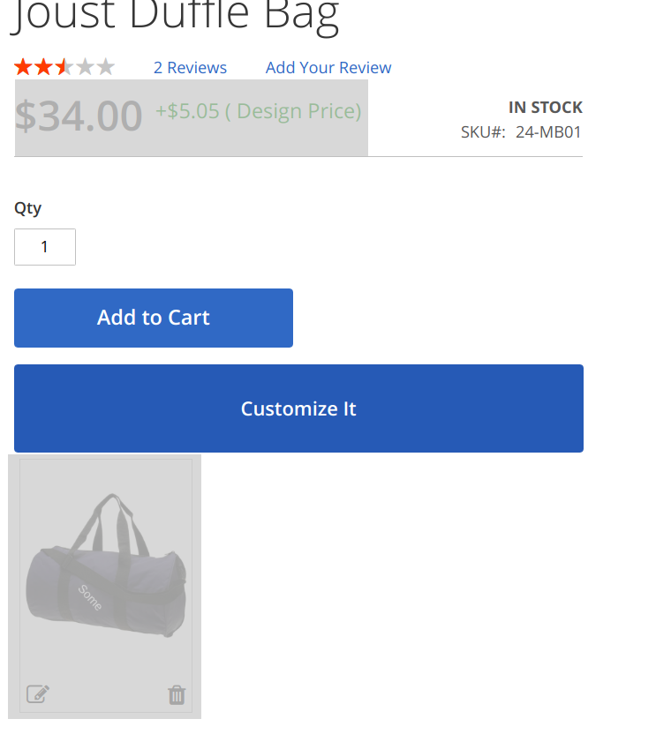

**3. Custom Product Configuration**

By default product with enabled «Product Designer» (**look above Front End enable**) shows main image for designer, if its **simple**. If its **configurable** «Product Designer» use main image from simple by selected configurable options, shows error if not selected all required options.

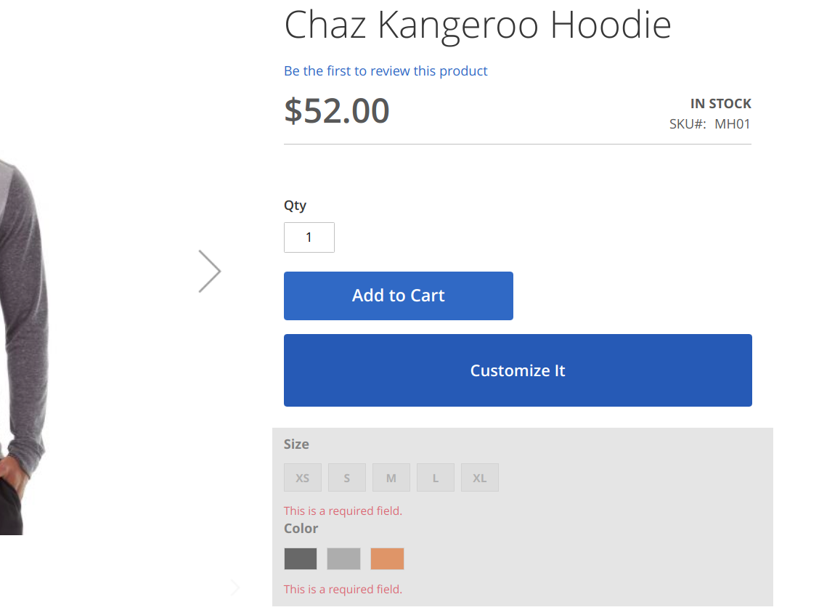

Its possible to specify Images Sets to design per simple or configurable product. Open edit product page, click on «Product Designer» section, then on «Configure Images» - button.

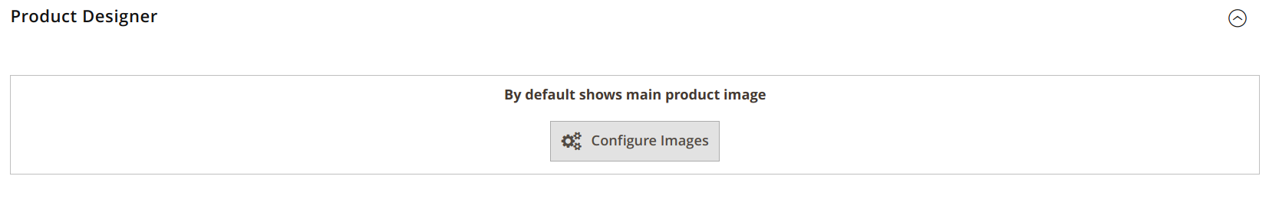

Showing configuration panel.

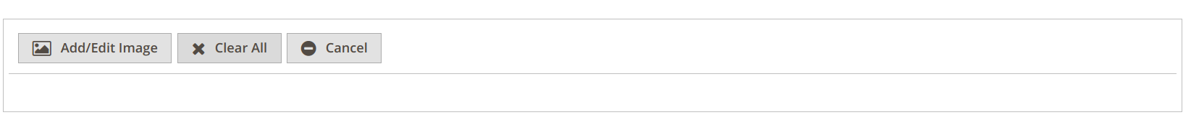

**Add/Edit Image** opens product images selection:

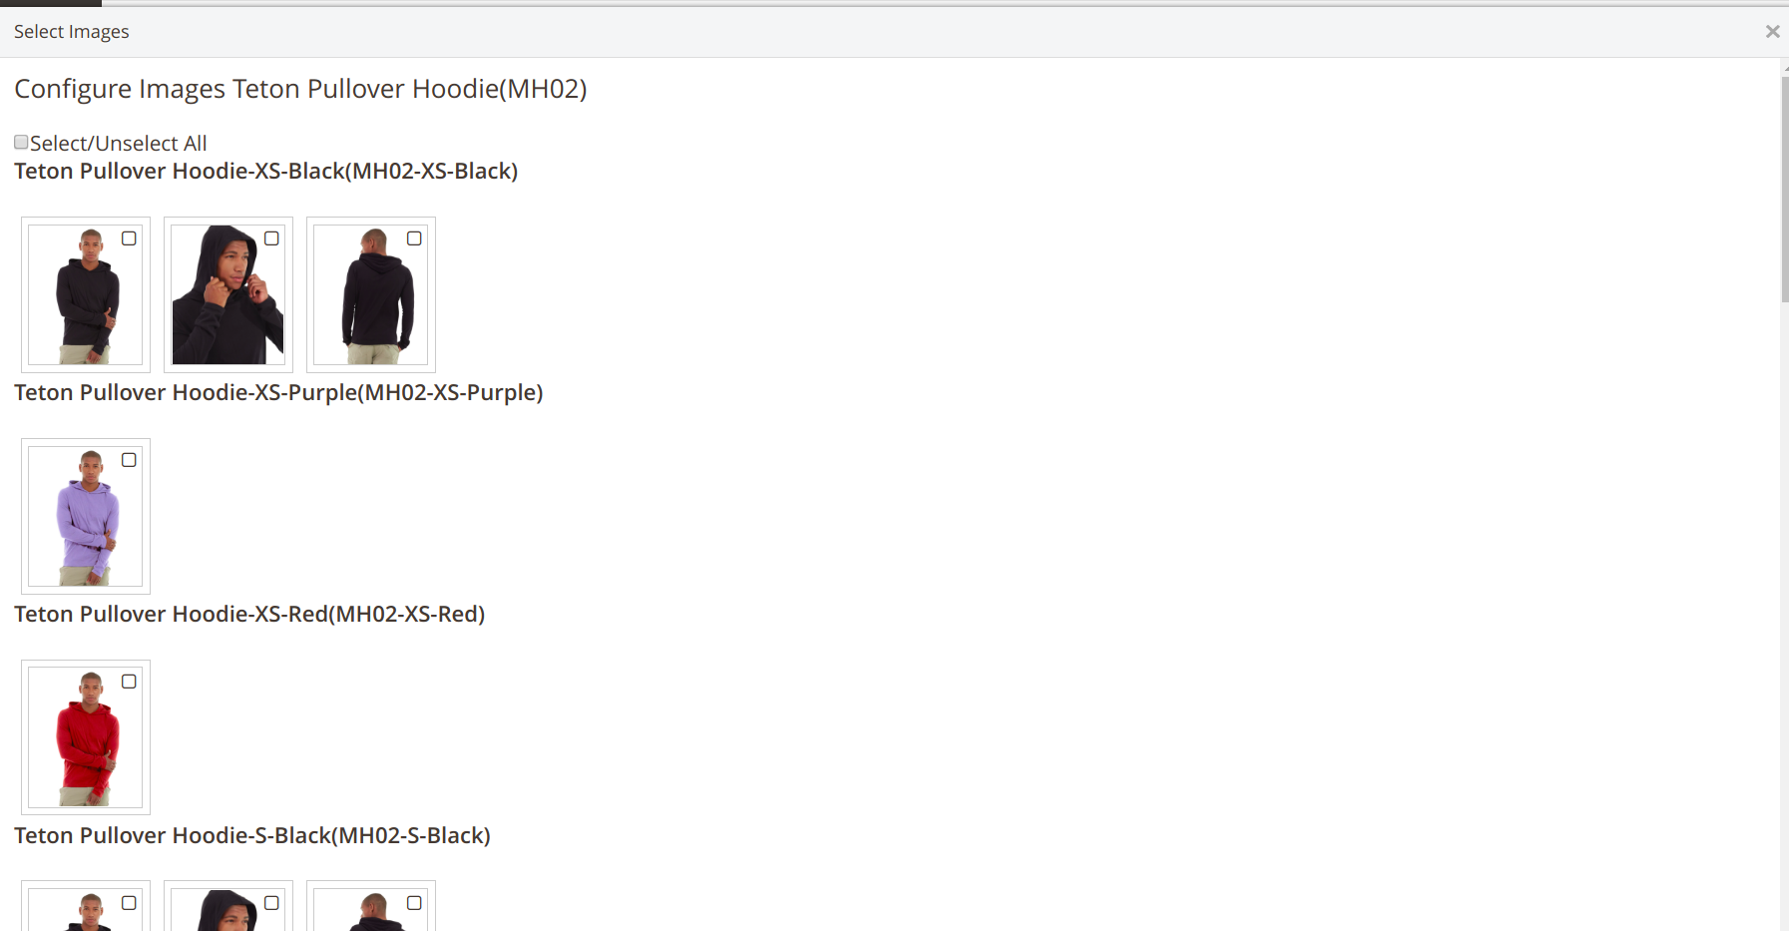

Image selections grouped by simple products if its configurable.

After select images close window using cross button (top-right);

To manage images which could be assigned for customization, use standart magento «Images and Videos» tab. (**simple** products)

For **configurable** products — manage images per each **simple** product.

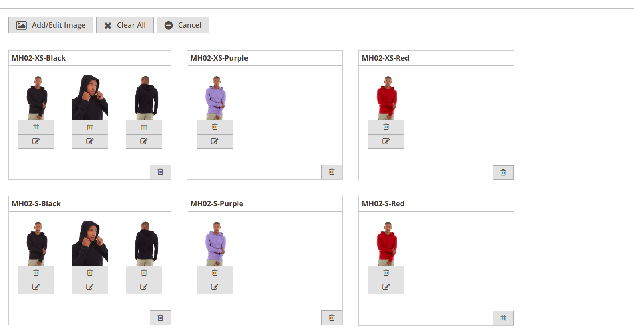

For manage customized images possible edit/delete each image, or delete group of images assigned to simple(grey buttons);

For configure images use grey — pen icon;

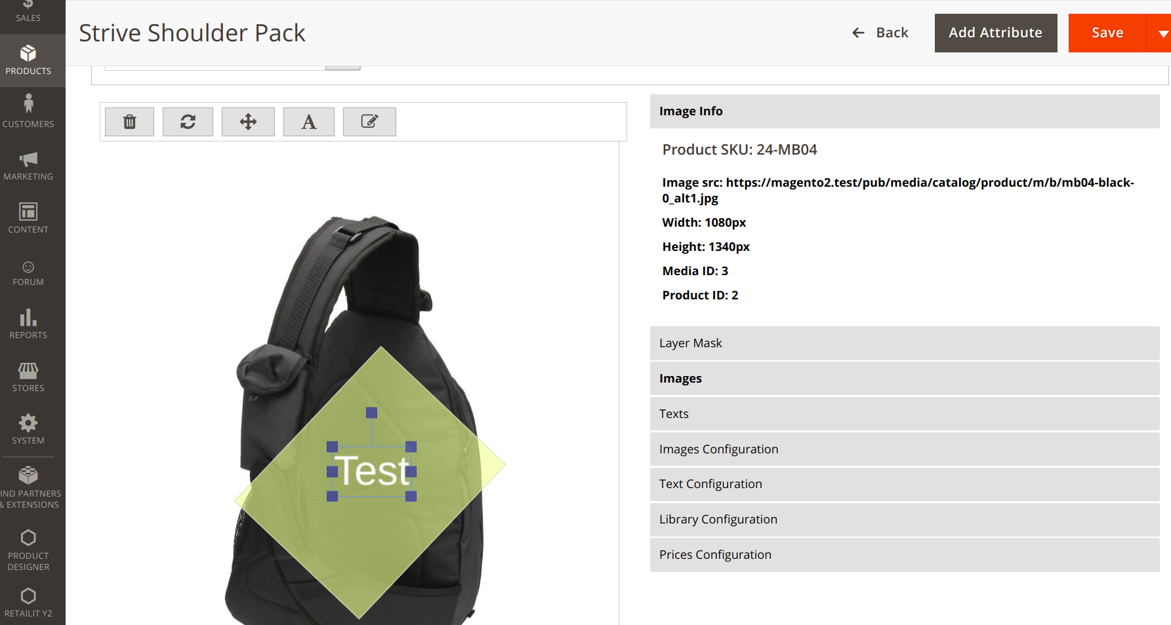

In right sections configuration Tabs:

**Image Info**  - shows main image information

**Layer Mask**  - setup «Product Designer» editable area

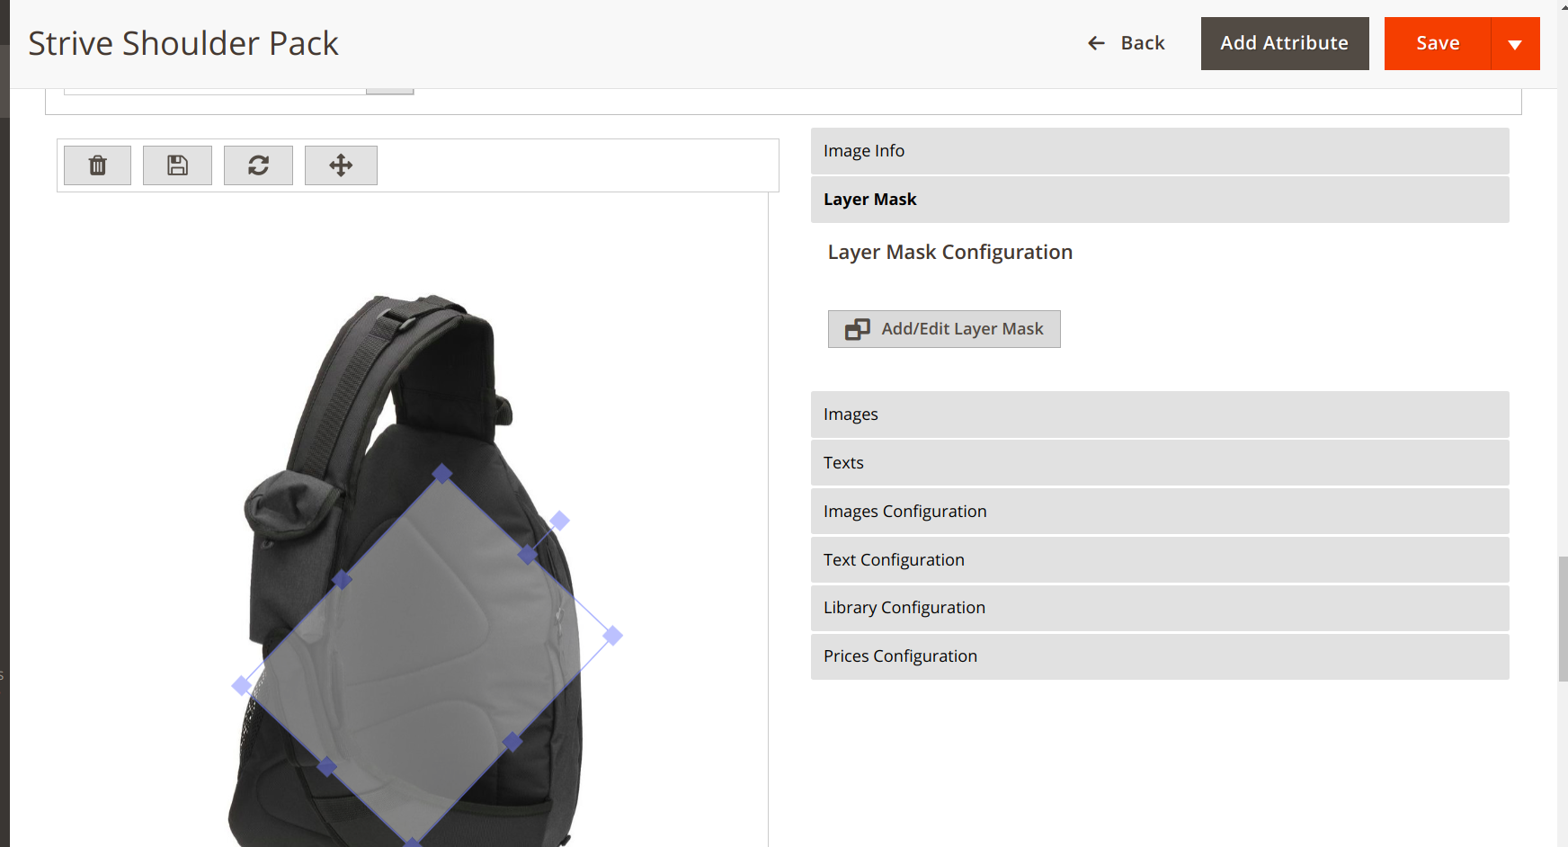

Top left icons — **Delete, Save(use it after layer mask created), Rotate, Resize.** Possible resize, move, rotate using mouse.

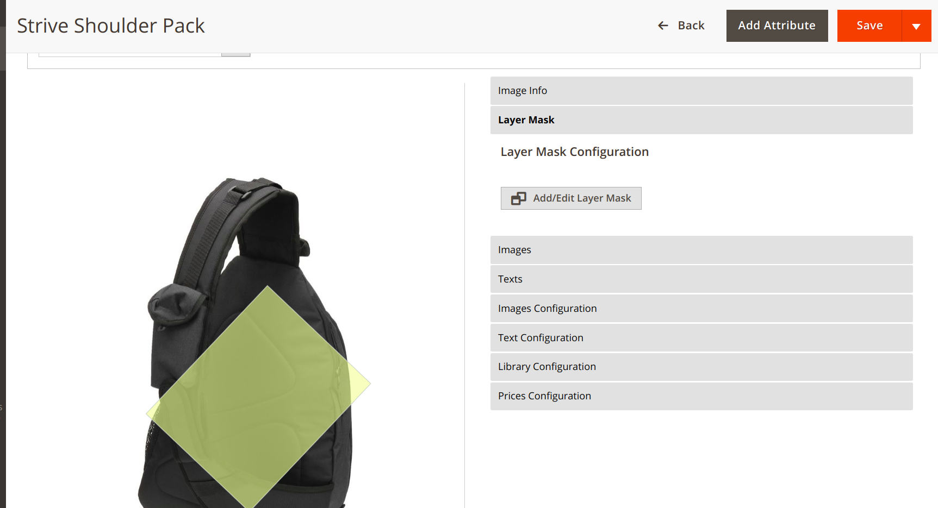

**Images**

Add/remove default images

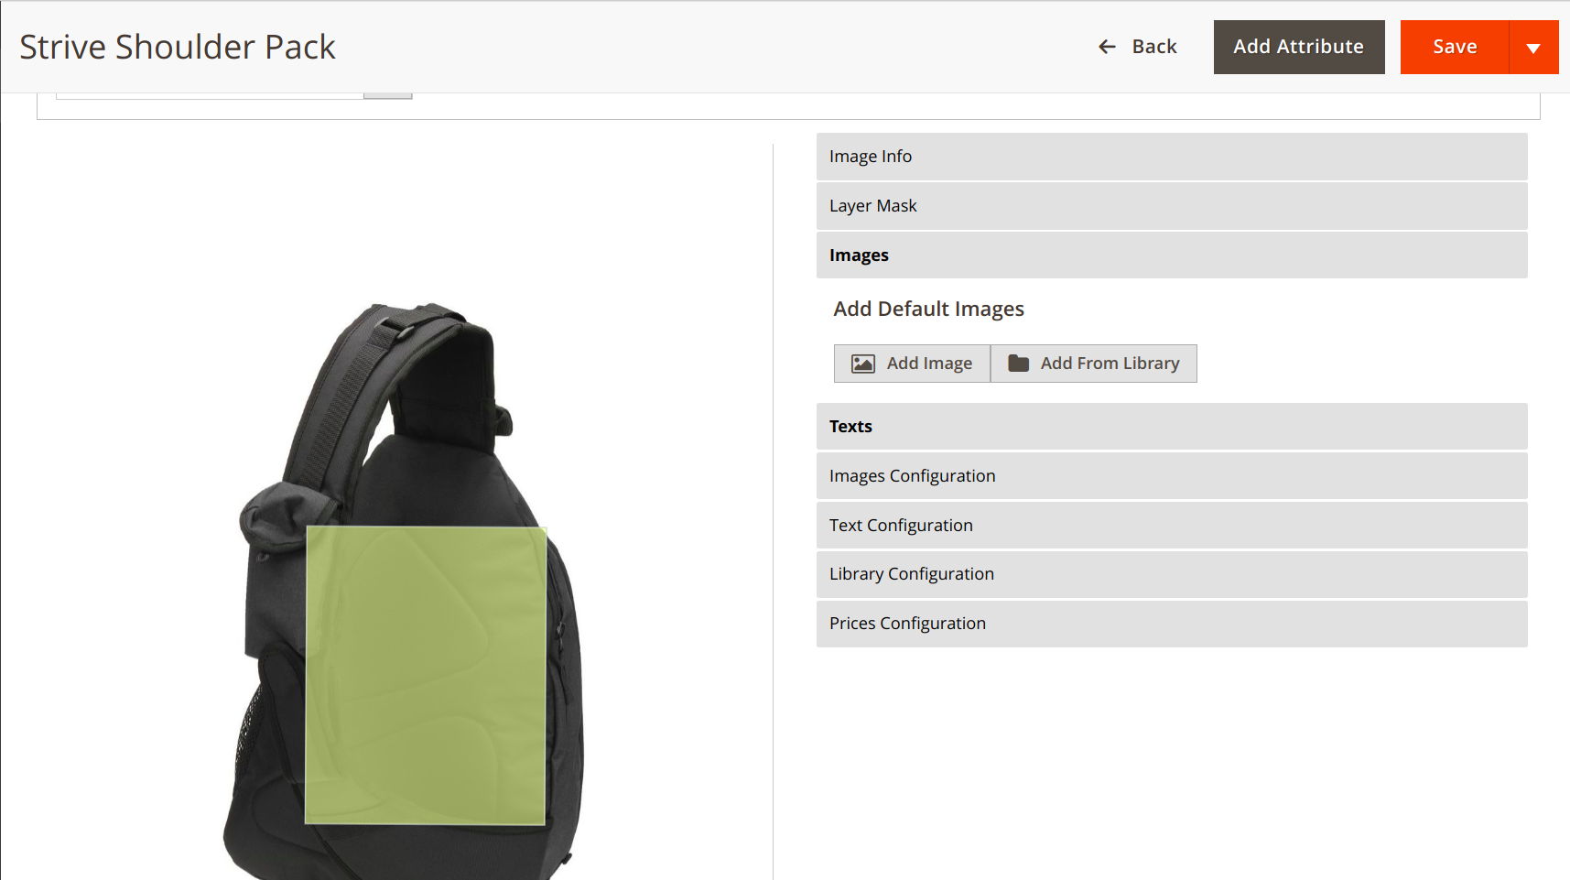

**Window «Upload» Tab** — uploading images from PC.**Window** «**My Photos» Tab** — select from already uploaded by admin images.

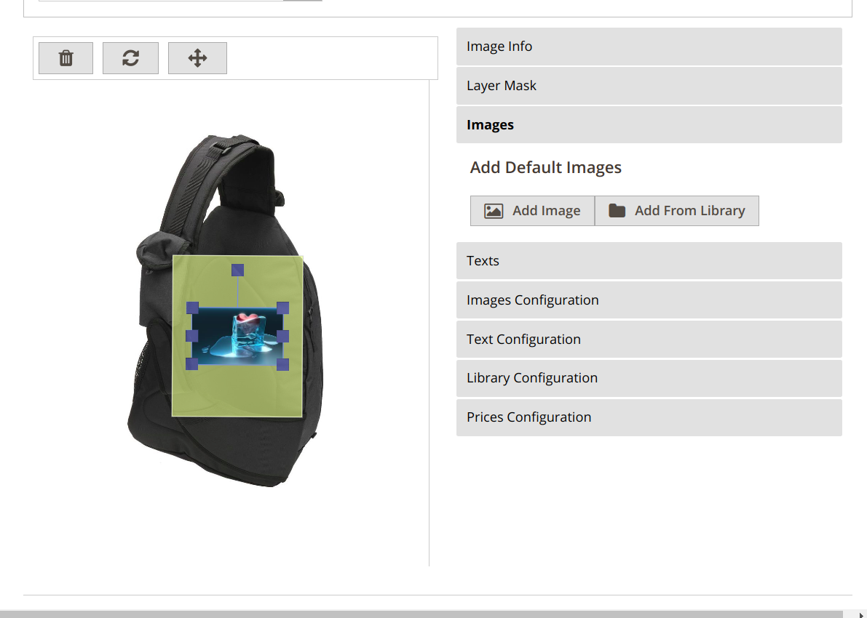

Top-left icons — **Remove, Rotate, Resize**.

**Texts** tab

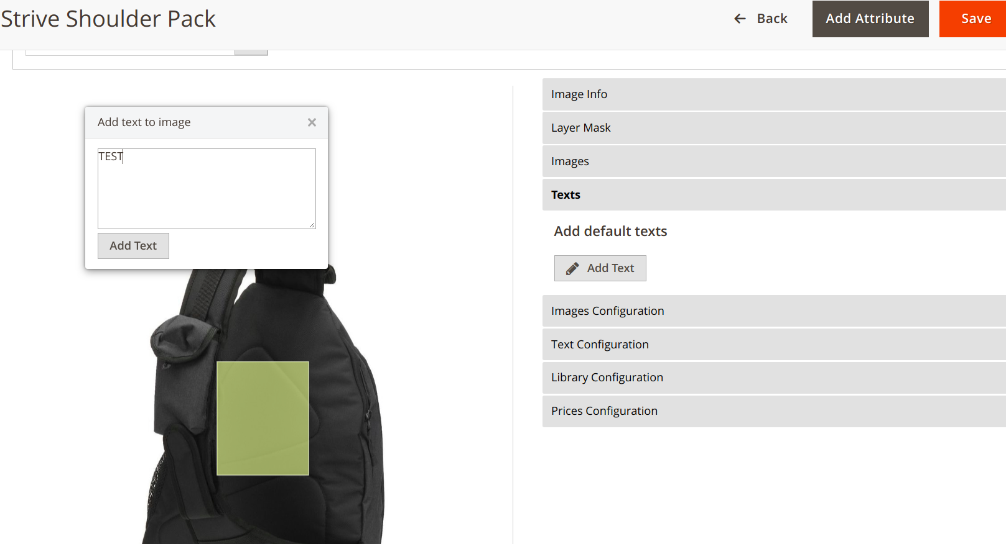

Add/edit default texts.

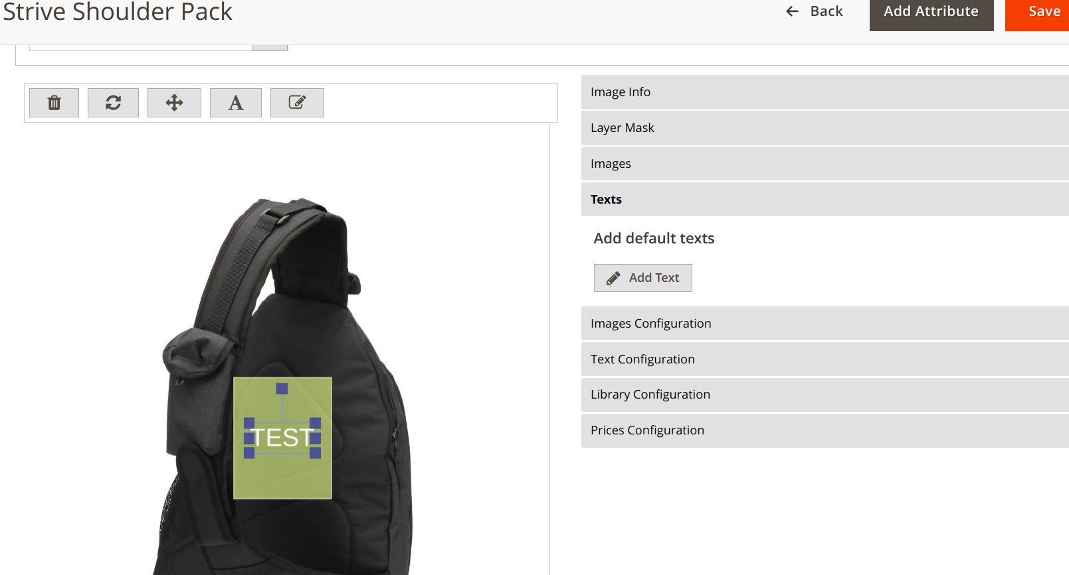

Top-left icons **Remove, Rotate, Resize, Text style(color, background, font-family), Edit (added text)**

As result default image and text will be showed on front view(don’t forget to press **«Save»** button):

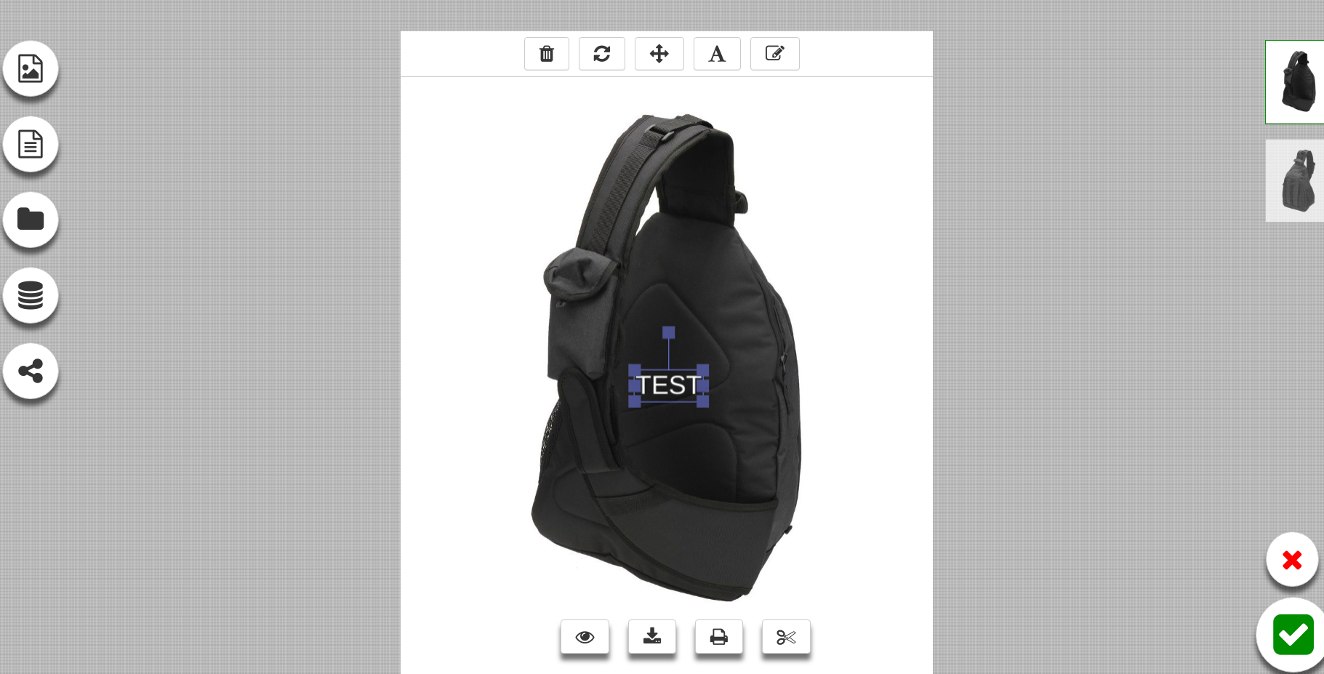

**Images configuration** Tab

Possible disable add photo button for front view, also controls for resize/rotate images

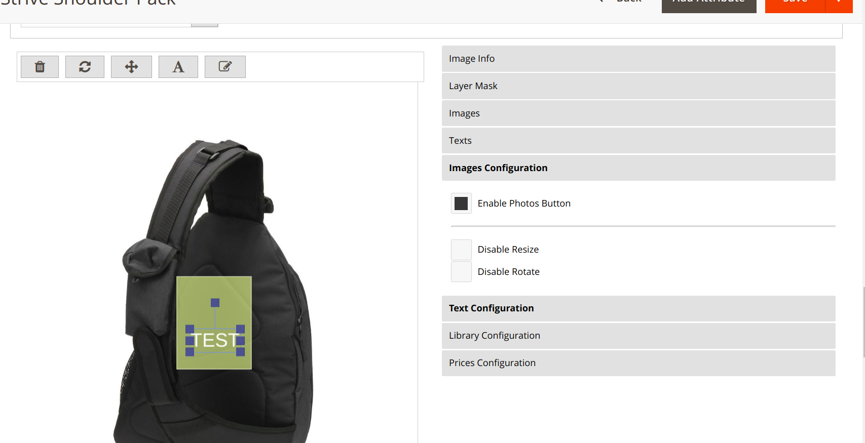

**Text Configuration** Tab

Disable add text button frons, controls rotate, resize, change background text color, list of available fonts and number of characters.

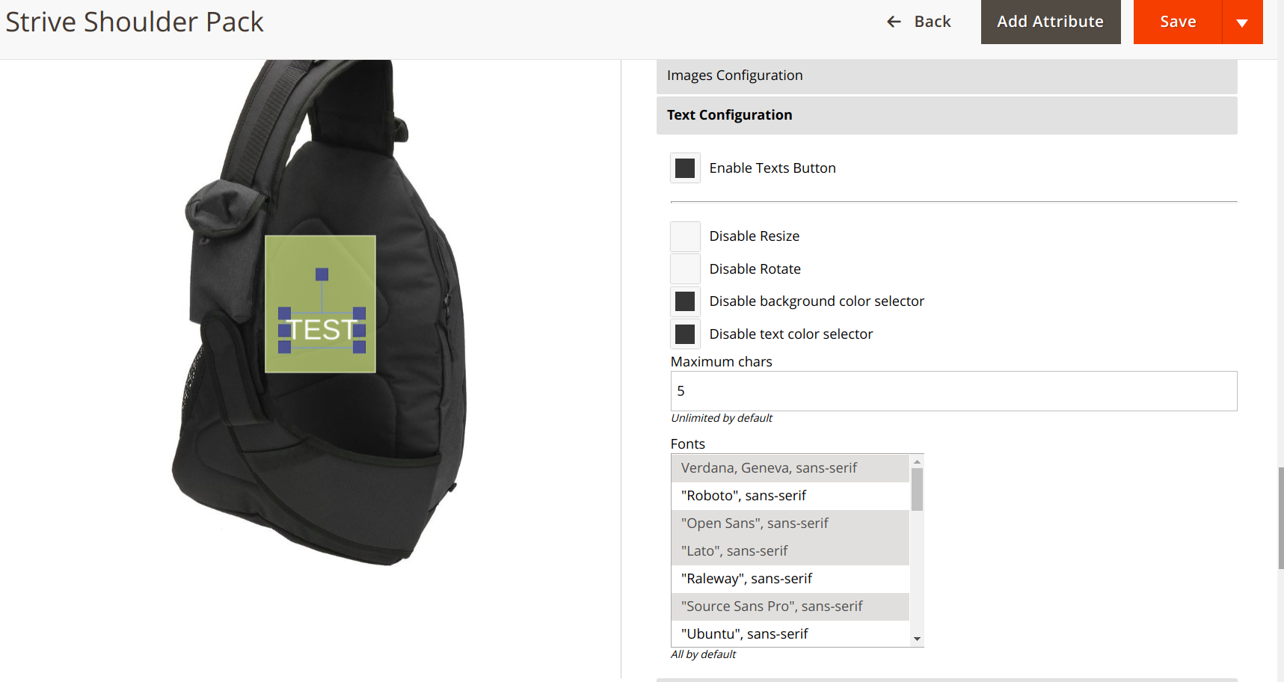

**Library Configuration** Tab

Disable/Enable Add from library button front, image categories folders(look above Add From Library section). Image Rotate/Resize controls are set in **Images Configuration** Tab.

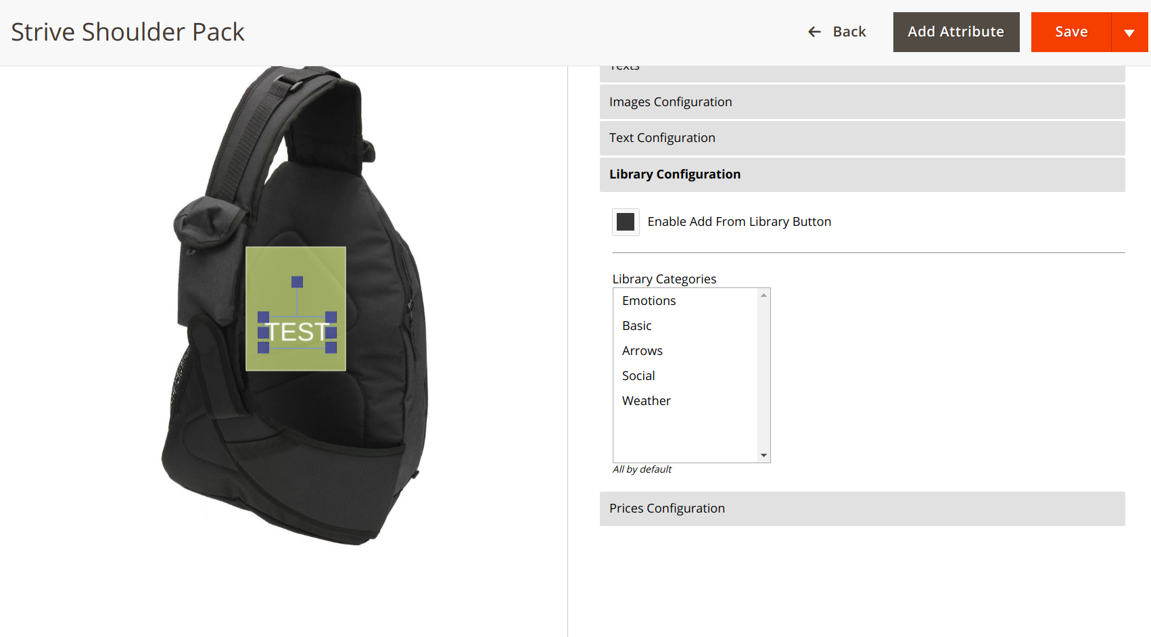

**4. Help Configuration**

To help your customer understand and use system for creation designed products, use help configuration already added to module.

There are already created **5** default **help** blocks. Each help blocks shows only once for customer.

**a.** **Customize button Block ID**

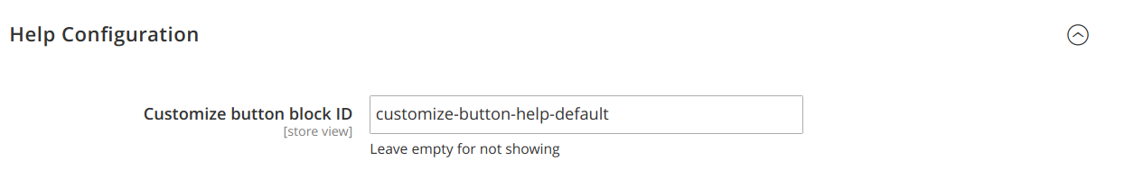

Content → Blocks to edit text inside the help popup.

Front end result:

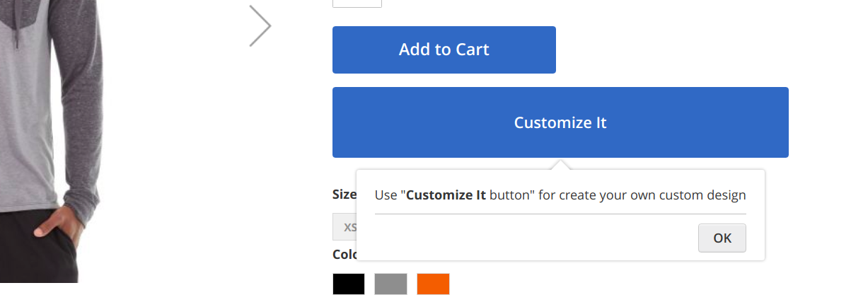

**b.** **Designer help 1 Block**

Help text for popup near «Add photo», «Add text», «Import from Library» etc.(left column)



Front end result:

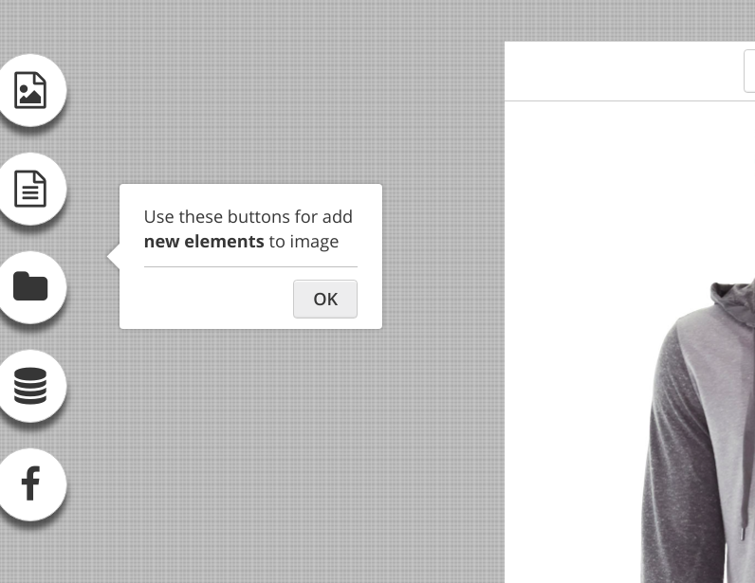

**c. Designer help 2 Block**

Help text above bottom controls(«Print», «Download» etc…)



Front end result:



**d. Designer help 3 Block**

Help text for «Save» and «Close»buttons(bottom-right)



Front end result:

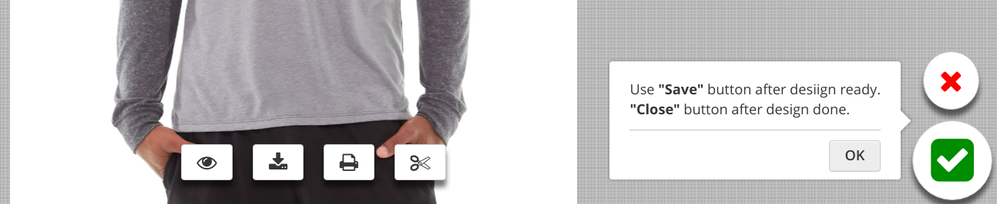

**e. Designer help switch images block**

Help text near switch images controls.



Front end result:

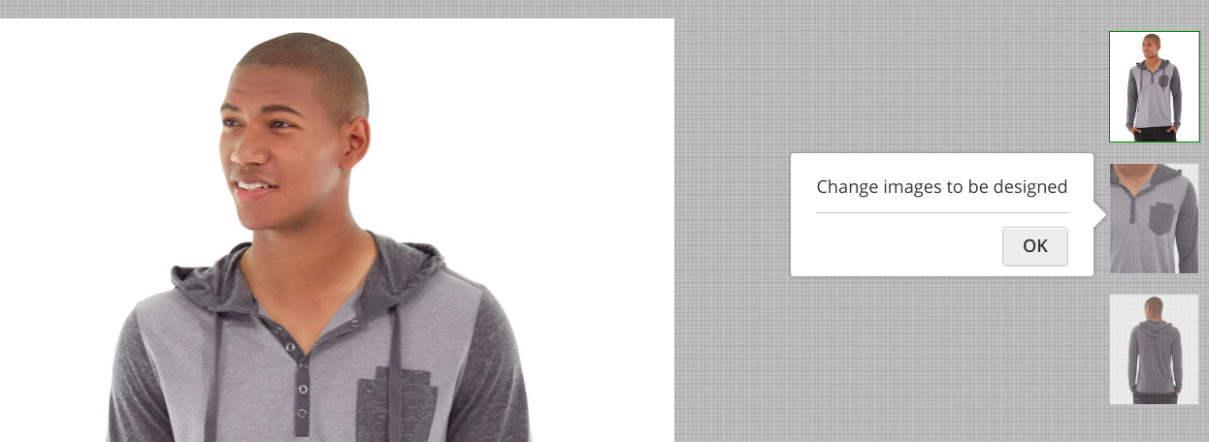

**5. Social Configuration**

Enable disable social images import(Facebook and Instagram) and Social Share Designs(Facebook, Twitter, Pinterest)

1. **Social Share**

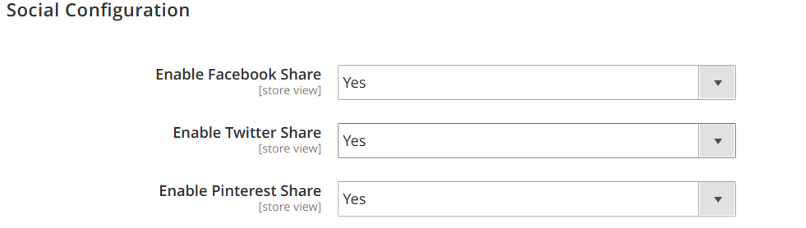

Frontend result:



Active share:

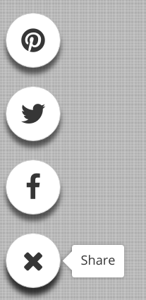

1. **Social Import Images from Facebook.**

Create facebook Application and get App ID and App Secret. More information about here - <https://developers.facebook.com/docs/apps/register/>

Important!!! Follow all the steps, and activate yours Application to **Live** mode. In **Sandbox** - mode your App have limited access to users account images.

Module Configuration:

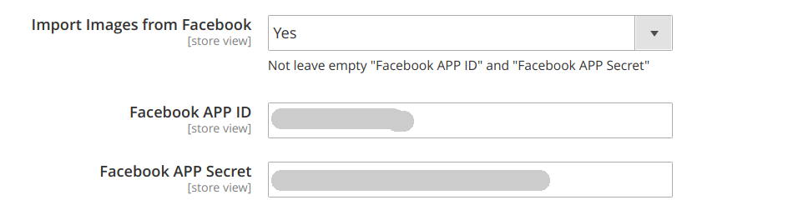

Front end result:

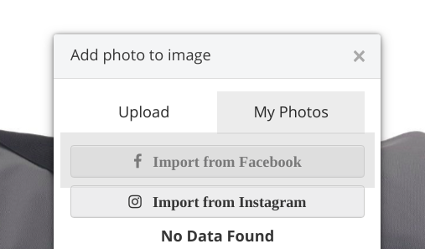

1. **Social Import Images from Instagram**

Create Instagram Client and get Client ID. More information about here - <https://www.instagram.com/developer/>

Important!!!. If Client are in **Sandbox** mode, possible only get images from users which are invited in **Sandbox**. After Client get **Live** mode, it could get images from any user who grant permissions for that.

Module Configuration:

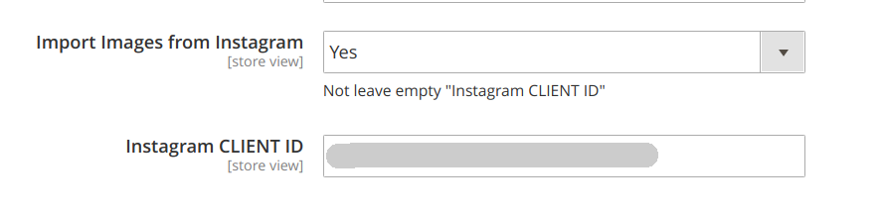

Front end result:

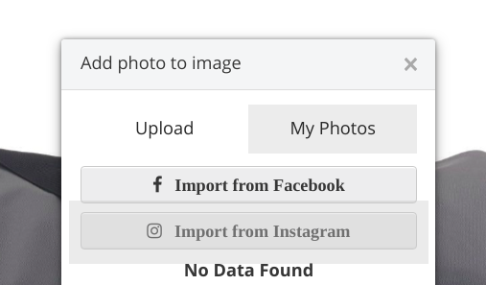

**ENJOY IT :-)**

Copyright 2018 Develodesign team